Alfa Laval signs major frame agreements for ballast water treatment retrofits
In June, Alfa Laval signed frame agreements with two different shipowners for the supply of Alfa Laval PureBallast systems. The systems will be delivered during a three-year period and retrofitted on tankers and bulk carriers.

The fleet orders were received from a tanker operator in the Middle East and a bulk carrier operator in Europe, who will time the booking of individual PureBallast orders with the scheduled dry docking of their vessels. Alfa Laval will make the first of its PureBallast system deliveries to the shipowners during the latter part of 2017.
“The Ballast Water Management Convention enters into force on 8 September of this year, and these frame agreements are a clear sign that the ballast water treatment market is moving forward,” says Kristina Effler, Manager Global Business Management, Alfa Laval PureBallast. “Shipowners are beginning to look beyond individual installations towards long-term solutions that will ensure compliance for their entire fleet.”

Many large-capacity Alfa Laval PureBallast systems
The framework agreements Alfa Laval has signed for PureBallast cover 45 systems and 8 systems respectively, many of which will handle a significant ballast water flow. The first order includes 22 systems with capacities of 2000 m³/h or 3000 m³/h, while the second order comprises four systems of 1500 m³/h and an additional four of 3000 m³/h.

“Low power consumption, a small footprint and high installation flexibility make PureBallast competitive for larger flows as well as smaller ones,” says Effler. “Flow rates of up to 3000 m³/h can be handled with a single, easily retrofitted PureBallast system. The signing of major orders involving so many large PureBallast systems shows that PureBallast is attractive across its capacity range.”

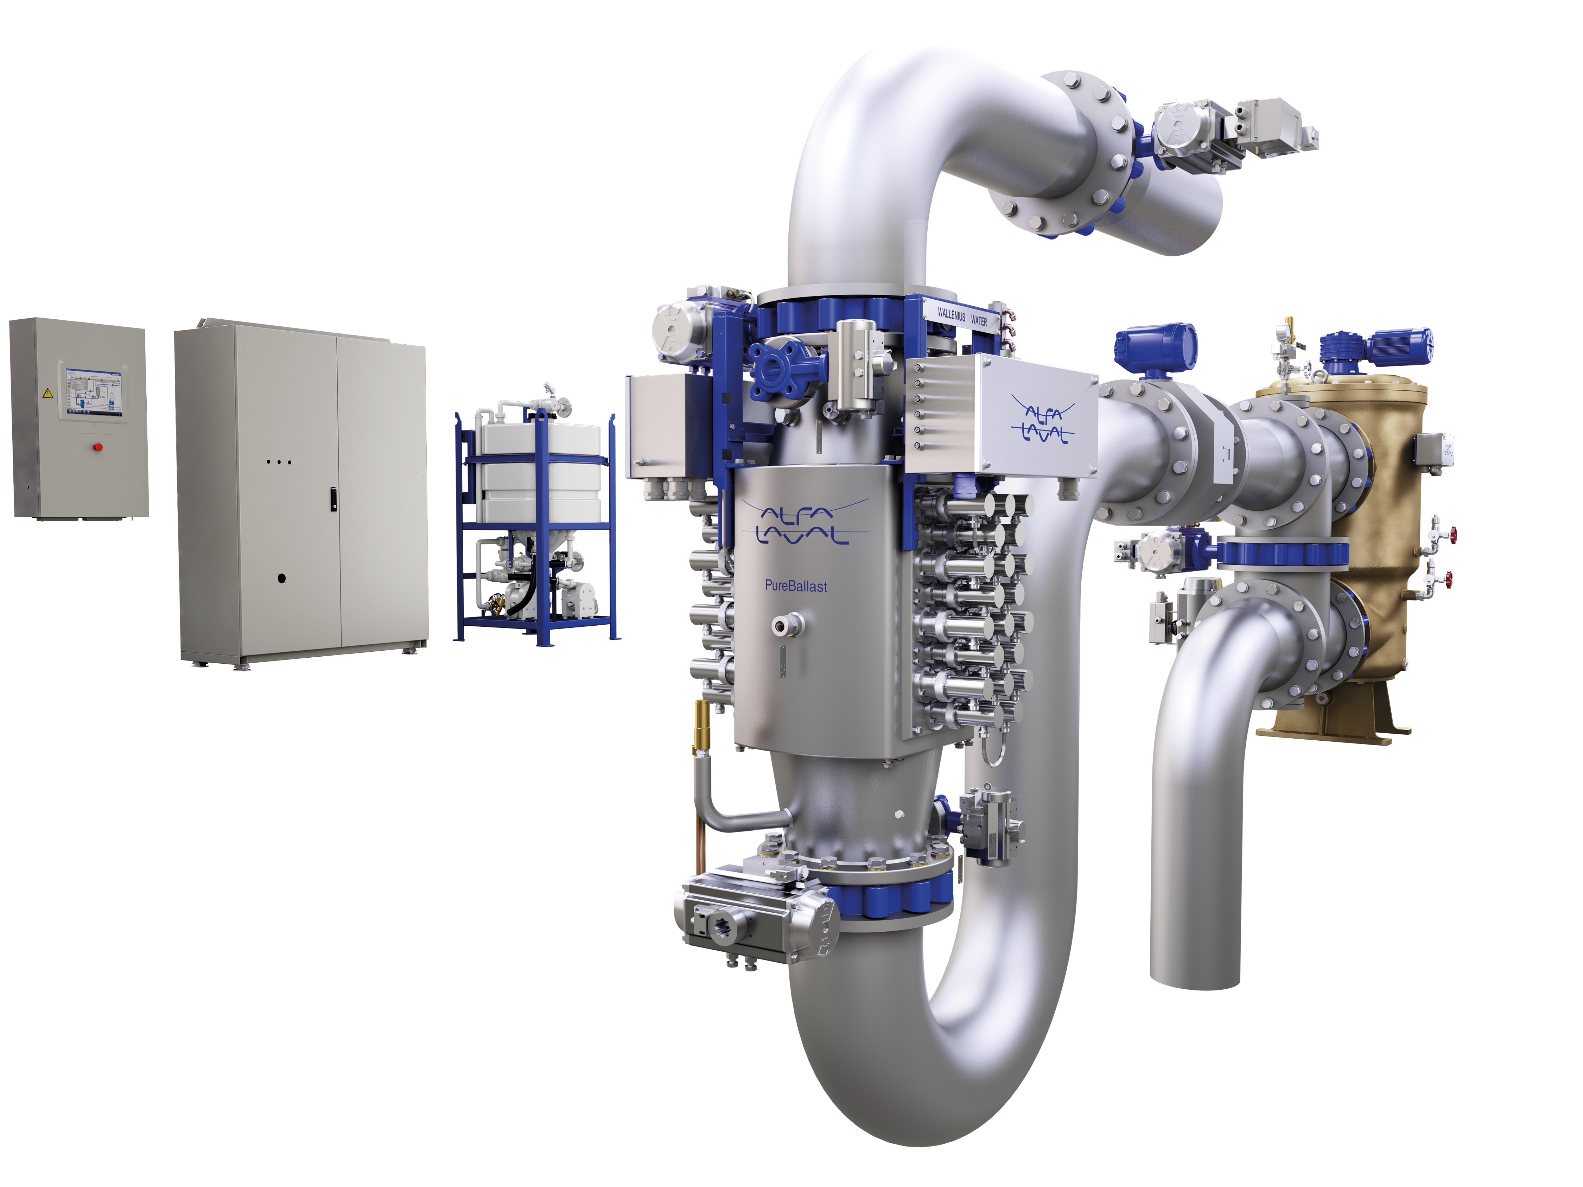
Image captions left to right:
Image caption 1: Kristina Effler, Manager Global Business Management, Alfa Laval PureBallast.
Image caption 2: Alfa Laval's PureBallast System

To learn more about Alfa Laval PureBallast and Alfa Laval’s approach to ballast water treatment, visit www.alfalaval.com/marine

Media contacts:
Kristina Effler
Manager Global Business Management PureBallast
Alfa Laval Marine Division
Phone: +46 8 530 650 28
E-mail: kristina.effler@alfalaval.com

Camilla Wallin
Marketing Communication Manager
Business Unit Marine Separation & Heat Transfer Equipment
Alfa Laval Marine Division
Phone: +46 8 530 653 58
E-mail: camilla.wallin@alfalaval.com

About Alfa Laval PureBallast
Alfa Laval PureBallast, which was the first commercially available ballast water treatment system, is a chemical-free system sold and serviced by Alfa Laval. A vital component of the system is the Enhanced UV Reactor, which was developed jointly by Alfa Laval and Wallenius Water based on Wallenius Water Technology.

www.alfalaval.com/marine

About Alfa Laval
Alfa Laval is a leading global provider of specialized products and engineering solutions based on its key technologies of heat transfer, separation and fluid handling.
The company’s equipment, systems and services are dedicated to assisting customers in optimizing the performance of their processes. The solutions help them to heat, cool, separate and transport products in industries that produce food and beverages, chemicals and petrochemicals, pharmaceuticals, starch, sugar and ethanol.
Alfa Laval’s products are also used in power plants, aboard ships, oil and gas exploration, in the mechanical engineering industry, in the mining industry and for wastewater treatment, as well as for comfort climate and refrigeration applications.
Alfa Laval’s worldwide organization works closely with customers in nearly 100 countries to help them stay ahead in the global arena. Alfa Laval’s worldwide organization works closely with customers in nearly 100 countries to help them stay ahead in the global arena. Alfa Laval is listed on Nasdaq OMX, and, in 2016, posted annual sales of about SEK 35.6 billion (approx. 3.77 billion Euros). The company has about 17 000 employees.

www.alfalaval.com

